Evaluation of Gross Domestic Products of Developed and Underdeveloped Countries Based on some Economic Panel Data

**(A Case Study of Africa and European Countries)**

# Introduction

A Nobel laureate Paul Samuelson and economist William Nordhaus once opined that the Gross Domestic Products and some other national income accounts might be mysterious concepts understood by few, they are a gift of the twentieth century, hence the need to explore and evaluate the Gross Domestic Products of countries based on panel data economic features. (Van den Berg, 2009) discussed Gross Domestic Products as a monetary and market value of all goods and services operated in a specific country with a period of a year, it is used to measure to ascertain the economic state of a country over some time or in relative to some other countries. The Gross Domestic Products has been used to evaluate the standard of living of citizens of a particular country, however, there are quite a lot of features that could be used to measure the GDP of a country some selected few such as citizens access to electricity, population growth, food export, and import, population total, fuel import and export, electric power consumption, electricity production from oil, gas, and coal then electricity production from oil sources. According to IMF, the Gross Domestic Products does not measure the general well being of citizens in a country, however, it could assist in the provision of economic health such that estimate of birth and death rate, inflation, consumption, and production of electricity fuel from oil, coal and gas, importation and exportation of fuel and food could be used to determine the effect of selected macroeconomic and microeconomic features on Gross Domestic Products.

# Background of the study

The healthiness of Gross Domestic Products is mostly used as an indicator that the economy of a specific geographic location is doing great with factors such as an increase in employment rate as people will be paid and they will purchase other goods and services hence increase in the consumption of fuel and electricity, reduced inflation whereas it is regarded as unhealthy when the rate of unemployment is on the increase, people will not get paid hence sluggishness in the transaction of goods and services in the region.

# AIM AND OBJECTIVES

This study aims to compare the relationship and effect of selected indicators on Gross Domestic Products between developed and developing countries, And also It aims to examine give us an insight between a developed country and underdeveloped countries such as poverty, availability of electricity, good infrastructural, unemployment, malnutrition, disease, lack of shelter, environmental degradation, insufficient scientific and technological resources, trade and payment imbalances, international debt, gender and ethnic discrimination, militarism and civil conflict, and lack of popular participation in economic and political life. with specific objectives as;

1. The correlation analysis of these indicators across developed and developing countries.
2. The regression analysis of these indicators across developed and developing countries.

# Hypothesis Formulation

**Null hypothesis**: There is no notable difference between the standard of living of selected African and European countries.

**Alternative hypothesis**: There is a notable difference between the standard of living of selected African and European countries.

Hypothesis Two

**Null hypothesis**: There is no notable difference between population growth in selected African and European countries.

**Alternative hypothesis**: There is a significant difference between population growth in selected African and European countries.

# Data Description

This section contains the description of indicators in the dataset and how they are represented as highlighted below. The dataset consists of 9 African and European countries each with a date range between 2001 and 2014, the countries are listed below.

Selected African countries: Benin, Botswana, Cote d'Ivoire, Cameroon, Ethiopia, Niger, Tanzania, Togo, and Zambia.

Selected European countries: Austria, Belgium, Cyprus, Denmark, Greece, Iceland, Ireland, Italy, and Netherlands.

**Access to electricity (% of population)**: The percentage of the population that has access to electricity supply.

**GDP growth (annual %)**: The yearly percentage growth of Gross Domestic Products.

**Inflation, consumer prices (annual %)**: The yearly percentage change in the price of goods and services purchased by the selected set of households.

**Population growth (annual %)**: The yearly percentage growth of the population of selected countries.

**Food exports (% of merchandise exports)**: The percentage of exported foods.

**Food imports (% of merchandise imports)**: The percentage of imported foods.

Population, total: The total population of selected countries.

**Fuel imports (% of merchandise imports)**: The percentage of imported fuel.

**Fuel exports (% of merchandise exports)**: The percentage of exported fuel.

**Electric power consumption (kWh per capita)**: The consumption of electricity measured in kilowatt per hour.

**Electricity production from oil, gas, and coal sources (% of total)**: The percentage of electricity produced from oil, gas, and coal sources.

**Electricity production from oil sources (% of total)**: The percentage of electricity produced from oil sources.

# Data Anonymization

The guideline for GDPR was met as the dataset did not reveal any personal information hence data anonymization was not carried out on the dataset.

# Data Preparation and presentation

### Data Cleaning

The Raw data was loaded and cleaned using excel power query editor.

The dataset set was open on an excel file

click on data on the toolbar icon

Select the data set range

Then click on from table/range

Afterward, the power query editor loads the dataset

Then I start the cleaning, by removing unwanted columns e.g series code and country code

Click on the transform on the toolbar. missing values were replaced by 0,

Series code and country code were removed

Country and series name was unpivoted other column

Series name was highlighted and click on pivot column

Then all the series name was readjusted to row and header and year changed column

Finally, the data set is cleaned and ready to import.

To import the dataset, click on the home toolbar, below the file.

Click on it to import the dataset, click on close, and load

select existing worksheet. And save you the work.

### Missing Values

There were seven missing values in the dataset with 1 missing from fuel import, 1 each from food import and export, 3 from fuel export, and 1 from access to electricity.

# Data Presentation

A column titled continent was added to the dataset in excel to reveal analysis by either Africa or Europe hence easier comparison of statistical measures. The dataset was imported into SAS Enterprise Guide through the import wizard as shown in figure 1 below.

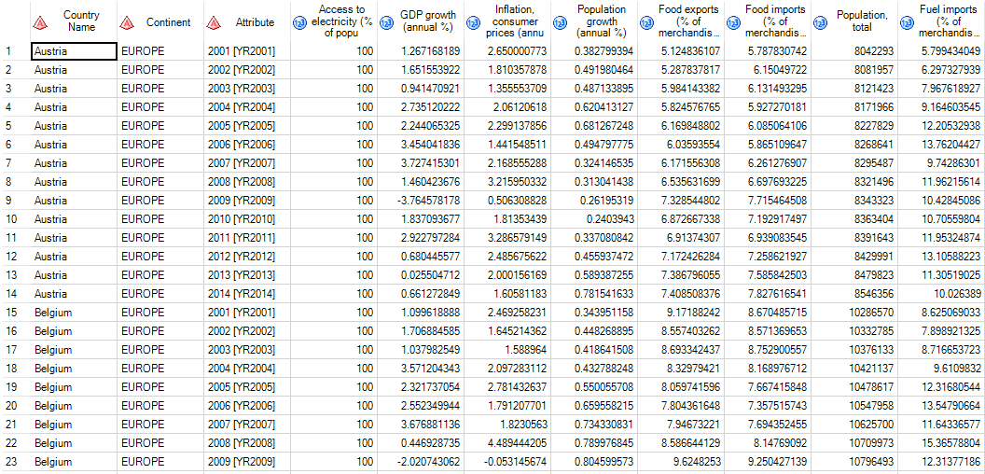

### Figure Data Presentation

# Descriptive Analysis

This section discusses the descriptive analysis adopted in this study as well as compare these measures by continent across the considered indicators, figure 2 showed the overall descriptive analysis of the dataset, which is a combination of both continents, while figure 2 and 3 revealed descriptive Africa and Europe respectively. The descriptive analysis was performed by selecting the summary statistics from the describe tab, all features were mapped under analysis variables while the skewness and kurtosis were added on the code tab with continent selected as the group by analysis.

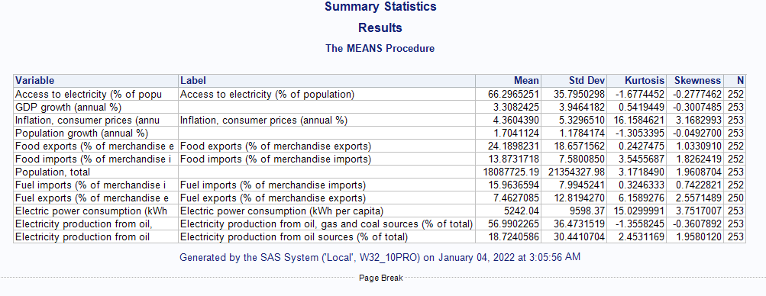

### Figure 2: Overall descriptive statistics

It could be observed from the figure above that access to electricity has a mean value of 66.2965, the standard deviation of 35.7850 (that is a deviation from the mean value), a kurtosis value of -1.67745 (that is the level of peakedness, claimed to be accepted at -2 to +2 (George et al., 2010)) and skewness value of -0.2777 (that is the measure of symmetry, claimed to be accepted at -2 to +2 (Hair et al., 2010)) hence the kurtosis and skewness measures revealed the normality of access to electricity as the values fall between the stated ranges. The GDP growth showed a mean value of 3.3082, the standard deviation of 3.9464 with a skewness (0.03007), and kurtosis (0.5419) value that showed it was normally distributed. The inflation, consumer prices with a mean value of 4.3604, the standard deviation of 5.3296, and a skewness (3.1682) and kurtosis (16.1584) value that revealed the indicator inflation, consumer prices not normally distributed. The population growth has a mean and standard deviation value of 1.7041 and 1.1784 respectively with skewness and kurtosis values of -1.3053 and -0.0492 respectively. The food export was normally distributed with skewness and kurtosis value of 1.0331 and 0.2427 respectively hence normally distributed with a mean and sta of 24.1898 and 18.6571. The food import has a mean value of 13.8732, standardized deviation value deviation of 7.5801, a skewness value of 1.8262 with kurtosis of 3.5456 though normally distributed by being symmetry but with higher peak, this also applied to population total indicator. Fuel import was shown to be normally distributed while fuel export was not distributed normally, power consumption was not normally distributed while electricity production from oil, gas, and coal sources was normally distributed but electricity production from oil sources only was slightly not normally distributed considering the skewness and kurtosis value of 1.9580 and 2.4531 respectively.

The descriptive analysis was made explicit by considering the descriptive measures by region as shown in Figures 3 and 4 respectively.

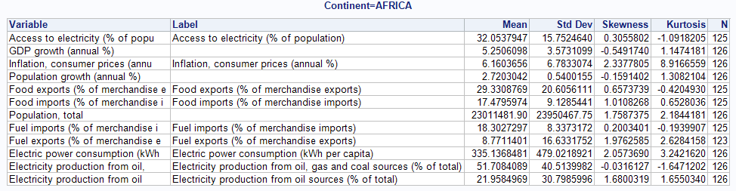

### Figure 3: Descriptive Analysis of Africa

The summary of the descriptive measures showed most indicators are normally distributed in African countries except the population growth with a higher peak of 8.9167 kurtoses and 2.3377 skewness value with an electric power consumption of 3.2422 kurtosis value and 2.0534 skewness value, with an observation that the missing values were reported from Africa continent.

# Correlation Analysis

The correlation analysis contributes to the explanation of economic behavior, aids in locating the crucial variables at which others depend, as it is likely to give out to economists or analysts the connections by which disrupt the spread and suggest to him the trail through which maintain pressure and may probability turn effective

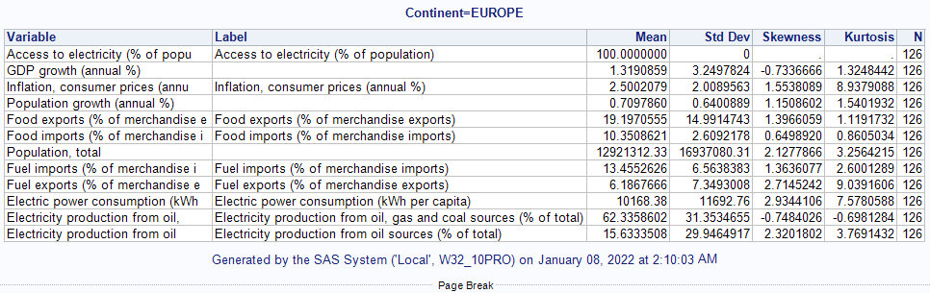

### Figure 4: Descriptive Analysis of Europe

The European countries steadily have access to electricity compared to Africa countries, while other indicators were reported to be normally distributed indicators such as population total, fuel import, and export electric power consumption, and electricity production from oil were not normally distributed considering the values of their skewness and kurtosis.

# Correlation Analysis

This statistical metric reveals the relationship that exists between selected indicators in this study across the considered continent, this shows if an increase in an indicator leads to an increase in the other or vice versa. The scatter plots visuals in the figures below explained the level of relationship between these indicators. This was done by selecting all features to be correlated under Analysis variables while creating a scatterplot for each correlation pair was ticked under result.

# Correlation Analysis of Indicators in Africa

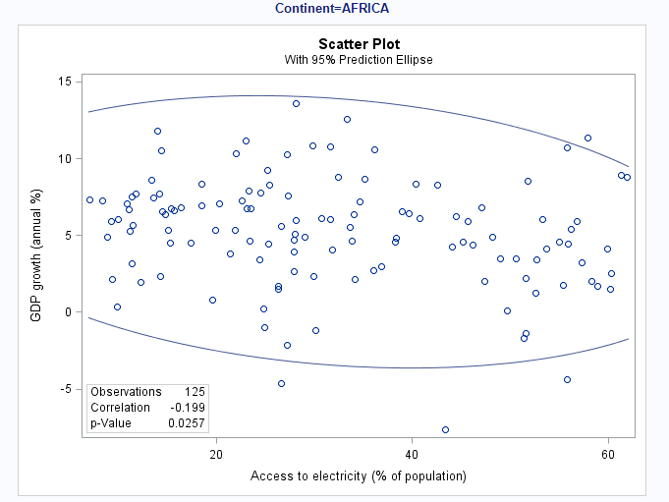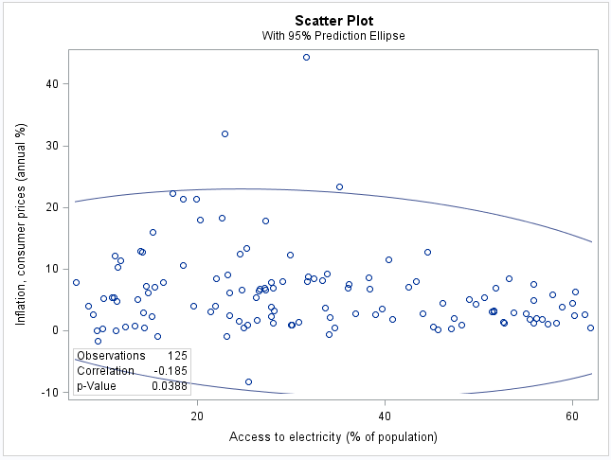

### Figure 5: Scatterplot of GDP and Access to electricity, Inflation, and Access to electricity

Figure 5 showed the correlation value between Gross Domestic Products (GDP) and Access to electricity as -0.1990 with a significant value of 0.0257, this means that access to electricity in Africa decreases the Gross Domestic Products by a value of -0.1990 and is significant because of the p-value 0.0257 < 0.05. There was a negative relationship between inflation and access to electricity with a value of -0.1850 with a significant value of 0.03.

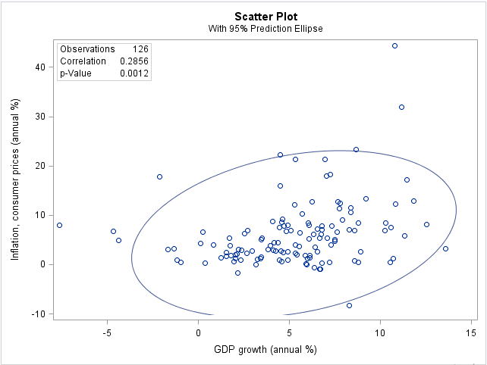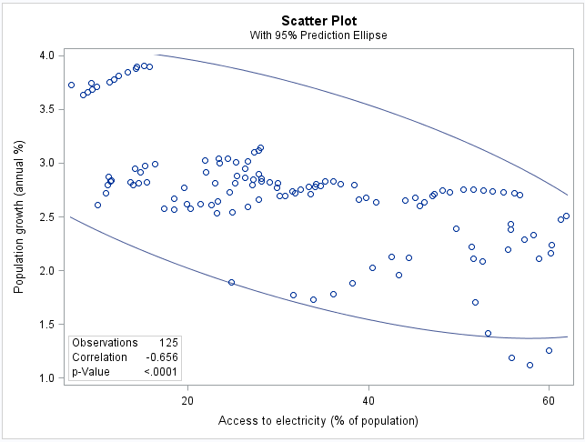

### Figure 6: Scatter plot of Inflation and GDP, Pop. Growth and Access to electricity

It was observed that an increase in Inflation also increases the Gross Domestic Products in Africa with a value of 0.2856 with a significant of 0.0012. The above revealed that an increase in population decreases the access to electricity in Africa with a correlation value of -0.656 with a significant value of < 0.0001.

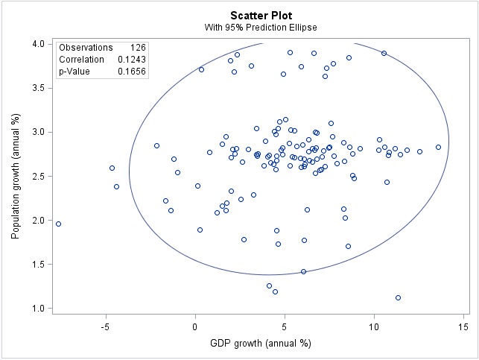 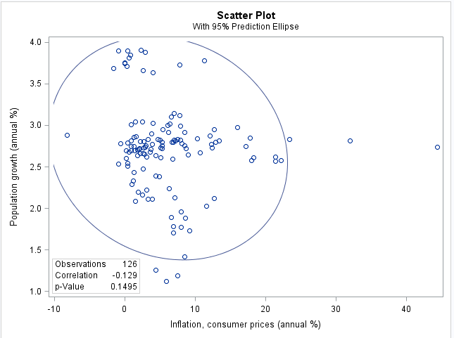

### Figure 7: Scatter plot of Pop. Growth and GDP, Pop. Growth and Inflation

It was observed that population growth increases gross domestic products growth of 0.1243 but is insignificant with a value of 0.1656 > 0.05. The second plot revealed there was a negative correlation with a value of -0.129 between inflation and population growth and insignificant with 0.1495.

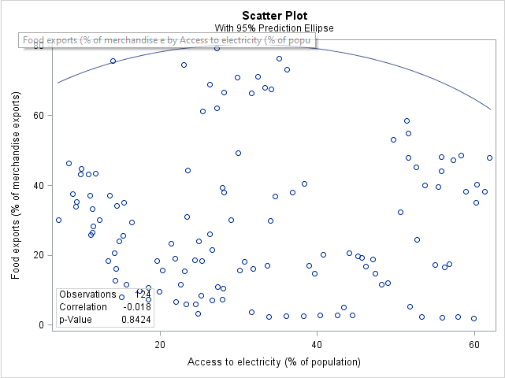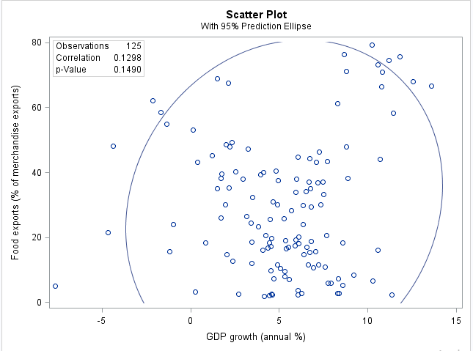

Figure 8: Scatter plots of food export and access to electricity, food export, and GDP

The figure above showed there was a negative relationship with a value of -0.018 with an insignificant value of 0.8424, but a positive correlation between food export and GDP with a value of 0.1298 but an insignificant value of 0.1490.

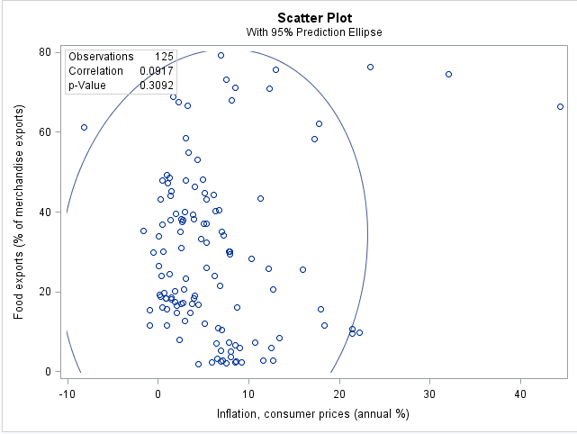 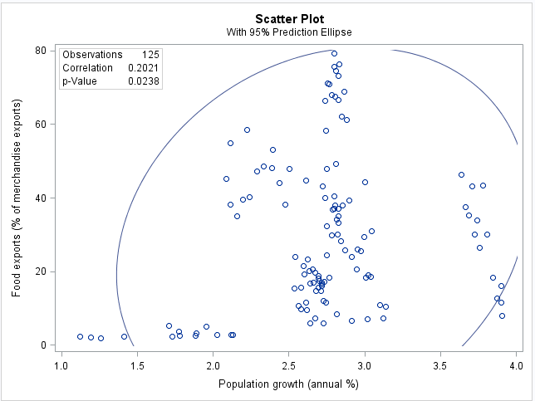

Figure 9: Scatter plots of Food Exports and Inflation, Food Exports and pop. Growth

The figure above revealed a correlation value of 0.0917 with an insignificant value of 0.3092 between food export and inflation while a positive correlation with a value of 0.2021 with a significant value of 0.0238 between food exportation and population growth in Africa.

### Correlation Analysis of Indicators in Europe

The correlation analysis of indicators as related to European countries was presented here.

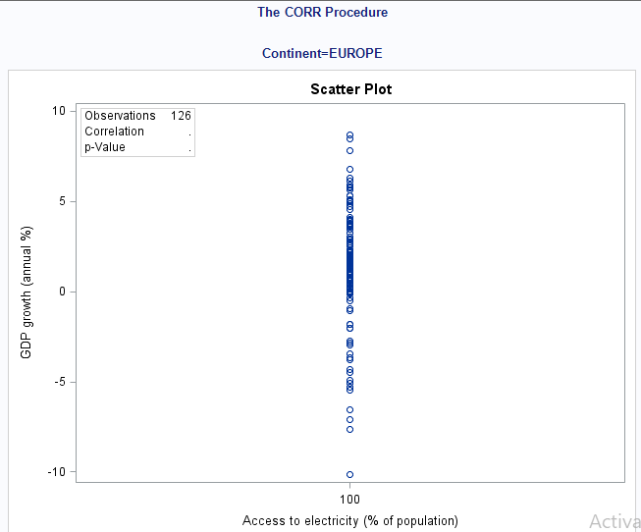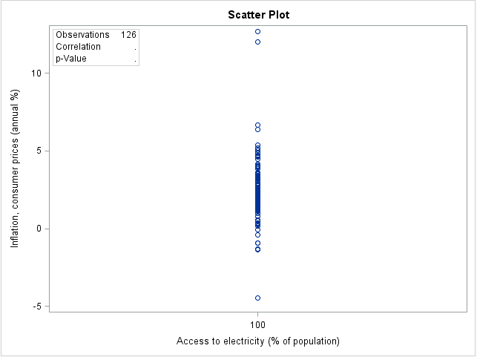

Figure 10: Scatter plots of GDP and Access to electricity, Inflation, and Access to electricity

From the figures above, it was revealed there was no correlation between GDP, Inflation, and Access to electricity in Europe.

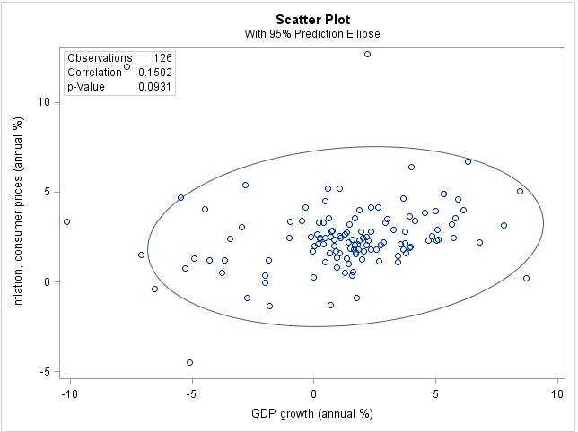 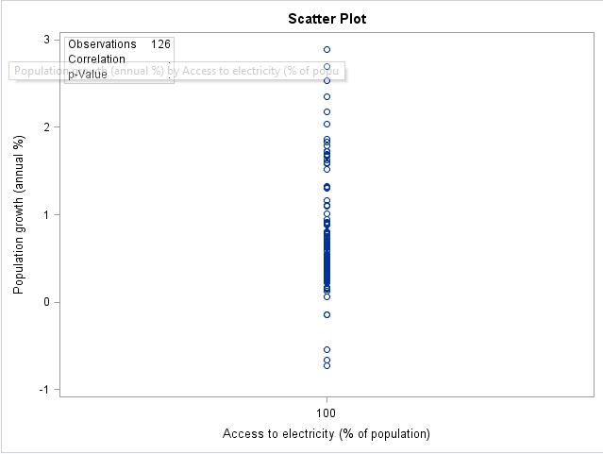

Figure 11: Scatter plots of GDP and Inflation, Pop. Growth and Access to electricity

It was revealed that there was a relationship between inflation and GDP with a value of 0.1502 with an insignificant value of 0.0931 while there was no correlation recorded between Pop. Growth and Access to electricity.

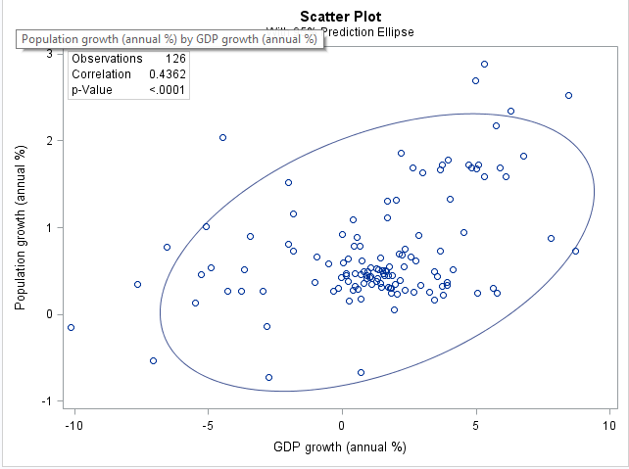 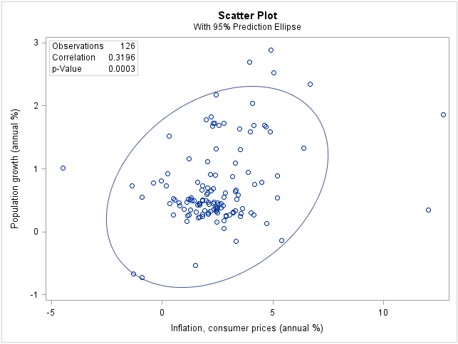

### Figure 12: Scatter plots of GDP and Pop. Growth, Pop. Growth and Inflation

There was a positive relationship that exists between Pop. Growth and GDP with a correlation value of 0.4362 with a significant value of < 0.0001 while a positive relationship was recorded for population growth and inflation with a value of 0.3196 with a significant value of 0.0003.

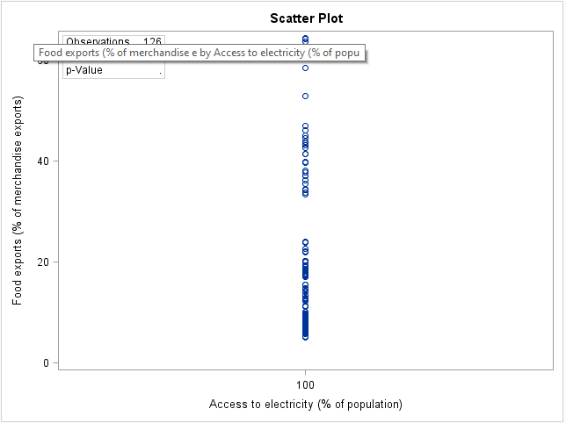 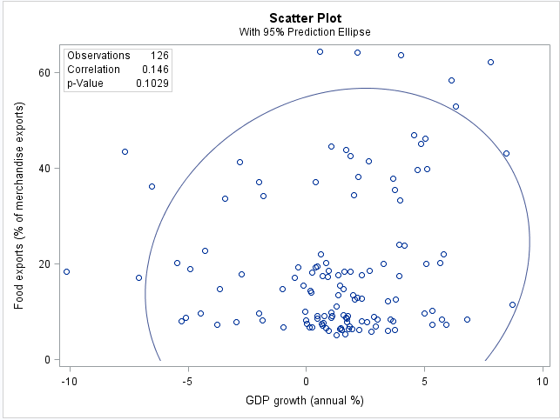

### Figure 13: Scatter plots of Fuel exports and Access to electricity, Food exports, and GDP

There was no correlation between food exports and access to electricity, while there was a relationship between food exports and GDP with a value of 0.146 and an insignificant value of 0.1029.

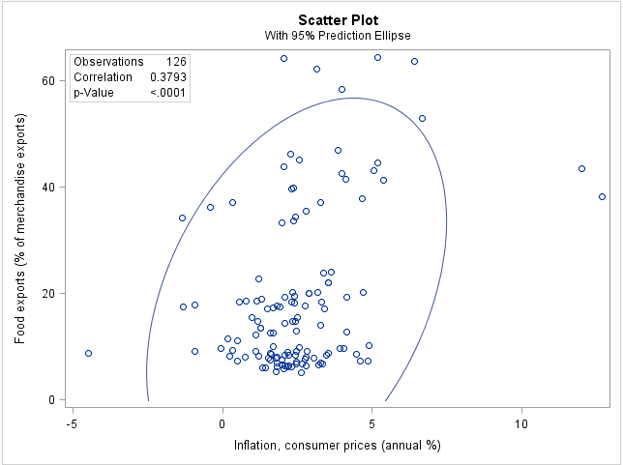 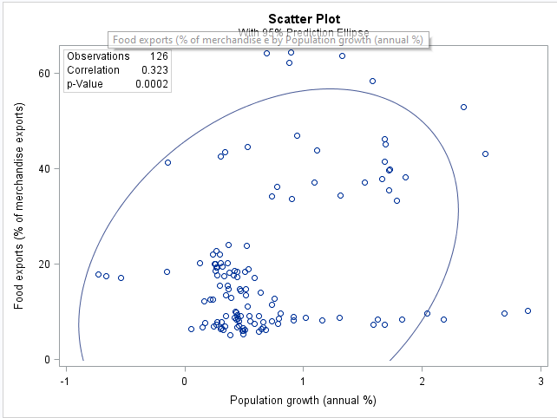

### Figure 14: Scatter plots of Food exports and Inflation, Food exports, and Pop. Growth

There was a positive correlation with a value of 0.3793 with a significant value of < 0.0001 while a positive correlation was recorded between population growth and food exports with a correlation value of 0.323 with a significant value of 0.0002.

# Correlation Analysis Summary of Africa and European Countries

Access to electricity was a problem in selected African countries as such a regressive result when related to gross domestic products, population growth, food exportation, and inflation compared to the other counterpart where access to electricity stood at 100% about other features. Inflation increases with food exports in African countries but decreases in European countries Though, gross domestic products increase with population growth for both continents the relationship level is higher in Europe compared to the African countries.

# REGRESSION ANALYSIS

Regression analysis is a statistical measure that is an estimate or prediction of the unknown value of one variable from the known value of other variables (Gupta). The gross domestic products serve as a measure to a range of the Products economy (WHO), hence Domestics Product multiple regression analysis of MatProc contribution of each feature towards the growth of gross domestic products across the two compared continents. Multiple linear regression has been implemented tat assist to in revel the impact of each independent feature report’s) on dependent feature (Y) Gross Domestic Products as represented in equation 1 below.

(1)

This was done by selecting that Analysis drop-down then selecting regression followed by linear regression, all independent features were selected under explanatory variable with GDP growth selected under dependent variable, then continent was mapped to group by.

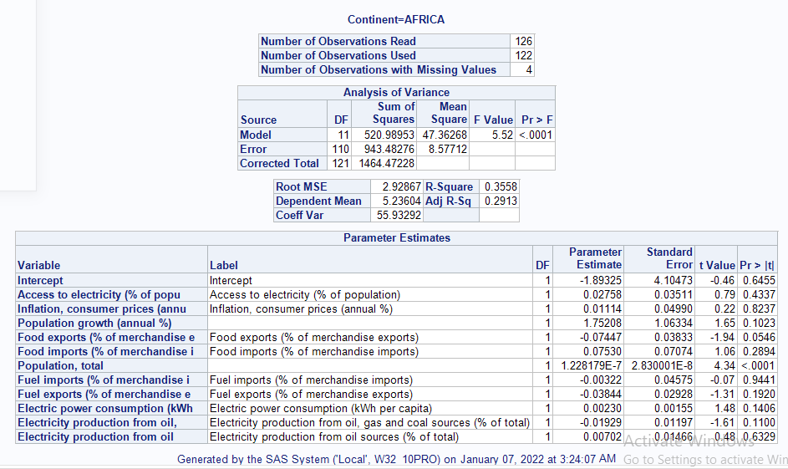

### Figure 15: Regression Analysis of African Countries

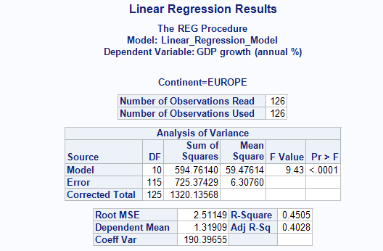

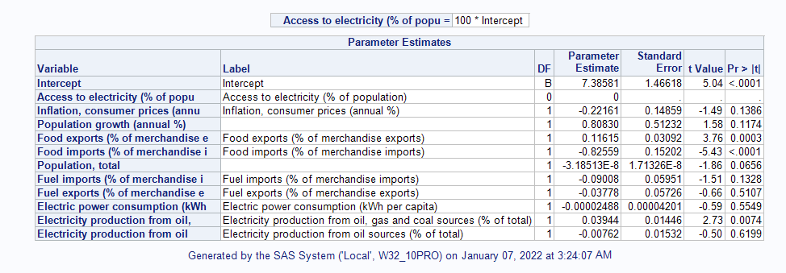

### Figure 16: Regression Analysis of European Countries

# Regression Analysis Summary of African and European Countries

The African model R squared has a value of 35.58% while Europe has a value of 45.05% this revealed the percentage of the data that was fit in the model, with a root mean squared error of 2.9287 for the African model and 2.5115 for the European model. From the model evaluation metric listed, the European model performed better than the African model has it possessed higher fit and lower root mean squared error

# Independents features effects on Gross Domestic Products in African Countries

This section discusses the summary of regression analysis obtained from both continents. A unit increase in access to electricity would yield an increase of 0.02758 in gross domestic products, a unit increase in inflation would yield an increase of 0.01114 in gross domestic products, a unit increase in food import would yield an increase of 0.0753 in gross domestic products, a unit increase in electric power consumption would yield an increase of 0.0023 in gross domestic products, a unit increase in electricity production from oil sources would yield an increase of 0.00702 in gross domestic products, while a unit increase in food exports would yield a decrease value of 0.07447 in gross domestic products, a unit increase in fuel imports would yield a decrease of 0.00322 in gross domestic products, a unit increase in fuel exports would yield a decrease in gross domestic products with a value of 0.003844, while a unit increase in electricity production from oil, gas and coal sources would yield a decrease in value of 0.01929 in Africa countries.

# Independents features effects on Gross Domestic Products in European Countries

A unit increase in inflation would yield a decrease in gross domestic products, a unit increase in food import yield a decrease of 0.82559 in gross domestic products, a unit increase in fuel imports yields a decrease in gross domestic products, a unit increase in fuel exports yields a decrease of 0.03778 in gross domestic products, a unit increase in power consumption yields a decrease of 0.00002788 in gross domestic products, and a unit increase in electricity production from oil sources yields a decrease value of 0.00762 in gross domestic products, while a unit increase in food exports would yield an increase of 0.11615 in gross domestic products, a unit increase in electricity production from oil, gas, and coal would yield an increase of 0.03944 in gross domestic products, and a unit increase in population growth would yield an increase of 0.80830. The obtained result from the analysis revealed that inflation, population growth access to electricity, electricity power consumption, and electricity production from oil sources were observed to increase the gross domestic product in African countries, while European countries have access to electricity, while population growth, food exports, and electricity production from oil, gas, and coal contributed significantly to increase in gross domestic products.

# Hypothesis Testing

A two-sample t-test was adopted as a statistic to measure the testing of the hypothesis since two continents are being considered hence a good metric for the study.

**Hypothesis One**

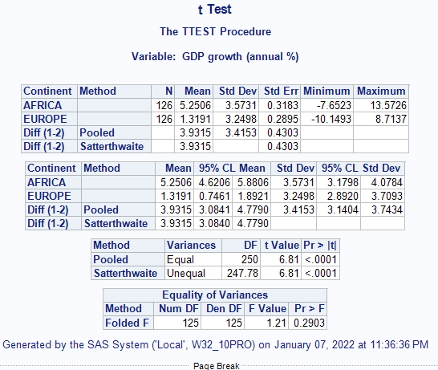

### Figure 17: Hypothesis test statistic for the standard of living

The rule of thumb for the selection of a null or alternative hypothesis is based on the condition that if the probability value is also known as tabulated is less than calculated then reject the null hypothesis and accept the alternative hypothesis otherwise reject the alternative and accept the null hypothesis.

The calculated value for the t-test (6.81) is greater than the probability or tabulated value (<0.0001) and the F-statistic reveal that f-value (1.21) > (0.2903) hence a rejection of the null hypothesis that there is no significant difference between the standard of living in African and European countries but acceptance there is a significant difference between the standard of living of the two compared continents.

### Hypothesis Two

Population growth is the only feature in the regression analysis that increases the gross domestic products in both continents, hence this study explored if population growth is significant across the continents.

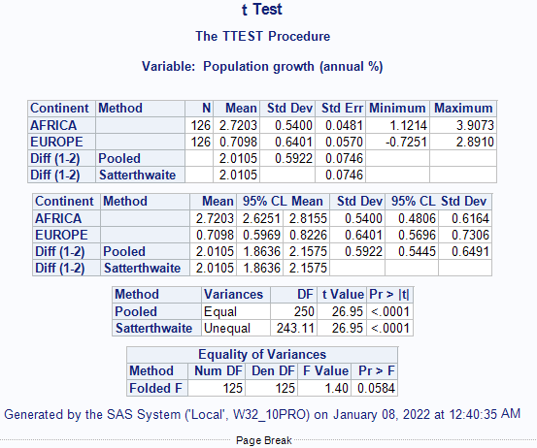

### Figure 18: Hypothesis test statistic for population growth

The calculated value for the t-test (26.95) is greater than the probability or tabulated value (<0.0001) and the F-statistic reveal that f-value (1.40) > (0.0584) hence a rejection of the null hypothesis that there is no significant difference between population growth in African and European countries but acceptance that there is a significant difference between population growth of the two compared continents.

# **Data Visualization with Tableau**

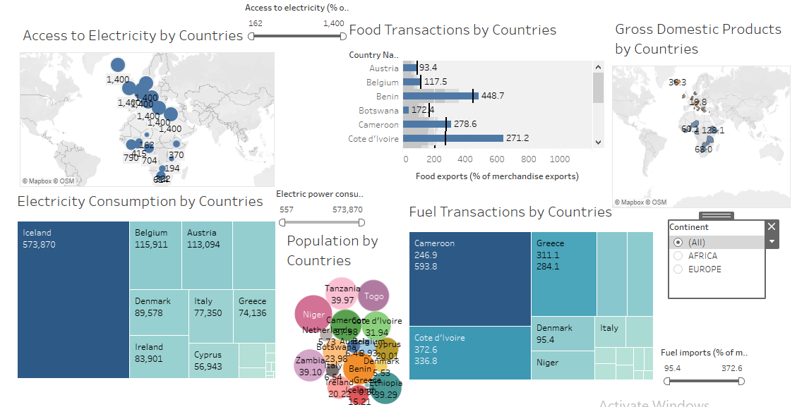

# **An overview of selected variables in the dataset in tableau brief explanation and Explanation of Data visualization process**

# Figure 19: Data visualization

The first visual was done by selecting (drag and drop) the access to electricity total indicator on the size option, while country was drop on the label with symbol map selected with electricity indicator being the measures while country serves as the dimension. The food transactions, import and export of food was visualized on a horizontal bar with food import and export representing measure metric while country serve as the dimension with food import dragged as the label. The gross domestic product was visualized by country on the maps with country being the dimension placed on a size while gross domestic product serves as the measures placed on label. The electricity consumption visual was done on a treemaps with electricity consumption indicator and country representing the dimension and measures respectively with country placed on size while the electricity consumption and country were placed on the label. The paced bubbles visual was used to visualize population by country with country as the dimension while population serves as the measure with both as the label. Lastly, the treemaps was used to visualize fuel transaction by country with both fuel export and import as the measure and country as the dimension, they were all placed on label to reveal the representation of fuel transactions among countries.

An interactive dashboard was created in Tableau Public with the features presented in the dataset, each sheet contains a visualization such as electricity consumption by a country that revealed the countries with most consumption by size as Iceland tops the list followed by Belgium and other selected European countries while African countries consumed the least of electricity. Access to electricity was visualized with a map plot that showed all European countries have full access to electricity compared to African counties. Food importation and exportation were visualized on a bar chart with countries like Togo, Benin, Cameroon, Cote D’Ivoire, Ethiopia, Tanzania doing great with Iceland, Greece, Cyprus, and Denmark also doing great in Europe while other countries flopped at export and import of foods. Also, the Gross Domestic Product growth was visualized on a map plot and was observed that African countries experienced higher growth in gross domestic product with Ethiopia topping the list with 128.1% growth compared to European counterparts such as Italy and Greece with -0.8 and -1.0 respectively. The population feature was plotted on a packed bubble with African countries with Niger, Benin, Tanzania, Ethiopia, Zambia, and Cameroon dominating their European counterpart like Greece, Denmark, Netherlands. While fuel transactions were visualized with treemaps and were observed that African countries such as Cameroon, Cote D’Ivoire, Niger transacted fuel the most in Africa compared to Europe where Denmark, Greece, and Italy. However not compared to the level of fuel transactions in African countries.

# Access to electricity

Electricity access is critical for poverty alleviation, economic growth, and improved living standards. Analysis of the proportion of people who have access to electricity is thus an important social and economic indicator. High-income countries – or countries defined as 'developed' by the UN – are assumed to have a 100% electrification rate from the first year the country entered that category. Energy efficiency can lead to the creation of new jobs. According to a recent study evaluating the impact of the EU's Eco-design Directive, the efficiency measures developed as part of the directive will result in 0.8 million additional jobs by 2020. 2 Furthermore, the energy services market provides an additional source of employment. Modern energy services are critical for assuring people's satisfaction with their lives and encouraging economic progress. Energy access is critical for issues such as

Energy access is critical for issues such as

1. security

2. global warming

3. Food production and economic growth while preserving ecosystems

4 Increased electrical availability benefits education, entertainment, health, comfort, security, and productivity.

5. It was discovered that having access to electricity benefited schooling for families since children could study more easily after dark. In addition, not having to go out and acquire fuel to burn saves time for everyone in the household, especially the women. Increased access to electricity also simplified household duties and boosted home business efficiency. Electricity access is critical for poverty reduction, economic growth, and higher living standards.

# Gross Domestic Product

Gross domestic product (GDP) is the total amount of final goods and services produced in an economy of a country. The GDP growth rate is one of the major indicators that show the state or status of an economy.

# Transaction by country.

Transactions within countries are varied and it can be in terms of exchange of goods and services, trade within the organization, fuel transaction by countries, food transaction by countries which all lead to the transaction and contribute to the rise in developed and underdeveloped countries GDP.

Furthermore, such transaction comes in terms of infrastructural amenities development, fuel importation, and exportation, raw material, food production exportation, that is focused on the aspect of an investment, however, when countries transact within themselves and in the foreign market, examples are the consumer, business organization, government counterpart in other countries those transactions become an inflow and outflow vice versa and lead to an increase in the nations GDP. The transaction which could be an inflow or outflow plays a significant role in a nation like employment level, economic growth, and balance of payment

# Conclusion

From the above analysis, it could be noted that considered European countries possessed a curated system such that an increase in inflation will decrease the gross domestic products of the countries, unlike the African countries that experienced an increase in gross domestic products when there is an increase in inflation, with increasing population also yielding a higher increase in gross domestic products compare to African countries with the more population than European countries.

**References**

Van den Bergh, J. C. (2009). The GDP paradox. *Journal of Economic Psychology*, *30*(2), 117-135.

<https://www.imf.org/external/pubs/ft/fandd/basics/gdp.htm>

George, D. & Mallery, M. (2010). SPSS for Windows Step by Step: A Simple Guide and Reference, 17.0 update (10a ed.) Boston: Pearson.

Hair, J., Black, W. C., Babin, B. J. & Anderson, R. E. (2010) Multivariate data analysis (7th ed.). Upper Saddle River, New Jersey: Pearson Educational International.

Neiswanger, William A., Elementary Statistical Methods, The Macmillan Co., New York.

S.C Gupta Fundamentals of Statistics

[https://www.who.int/data/nutrition/nlis/info/gross-domestic-product-(GDP)-per-capita-and-GDP-per-capita-annual-growth-rate](https://www.who.int/data/nutrition/nlis/info/gross-domestic-product-(gdp)-per-capita-and-gdp-per-capita-annual-growth-rate)

Energy Development and Poverty Reduction. (March 14, 2015). Rural Electrification [Online]. <http://www.energyfordevelopment.com/2010/04/rural-electrification-by-numbers.html>

 World Bank. (March 14, 2015). EnergyOverview [Online]. Available: <http://www.worldbank.org/en/topic/energy/overview#1>

[Jump up to:3.0](https://energyeducation.ca/encyclopedia/Access_to_electricity#cite_ref-IEA_3-0) [3.1](https://energyeducation.ca/encyclopedia/Access_to_electricity#cite_ref-IEA_3-1) International Energy Agency. (March 14, 2015). Energy Poverty [Online]. Available:  <http://www.iea.org/topics/energypoverty/>

**Appendix**

**Descriptive Statistics**

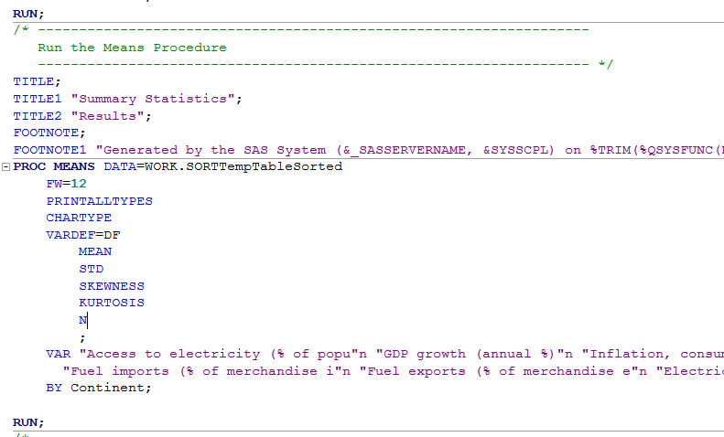

**Correlation**

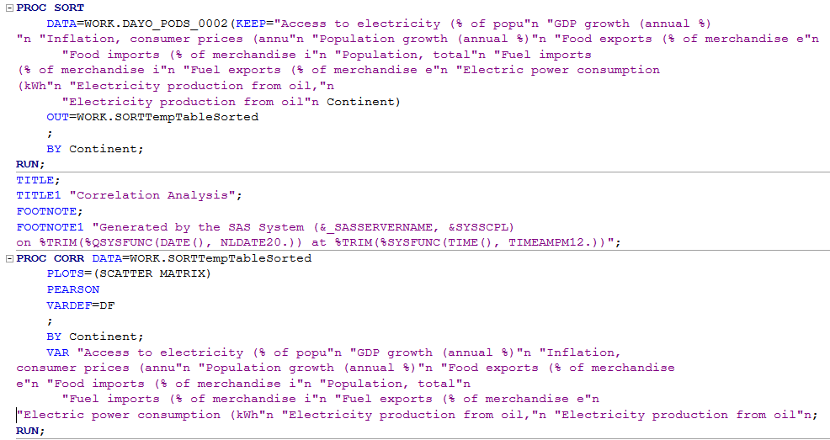

**Regression**

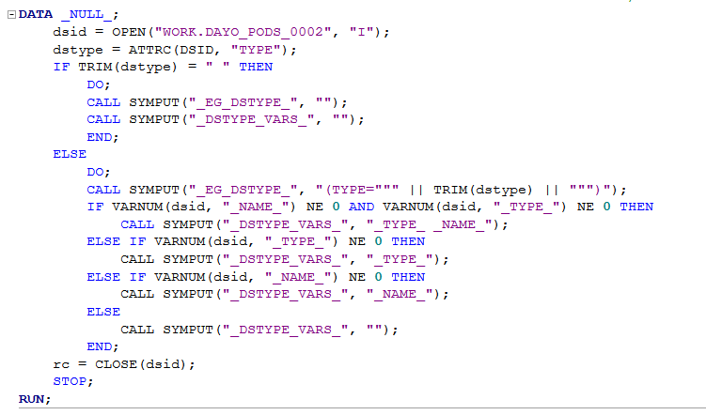

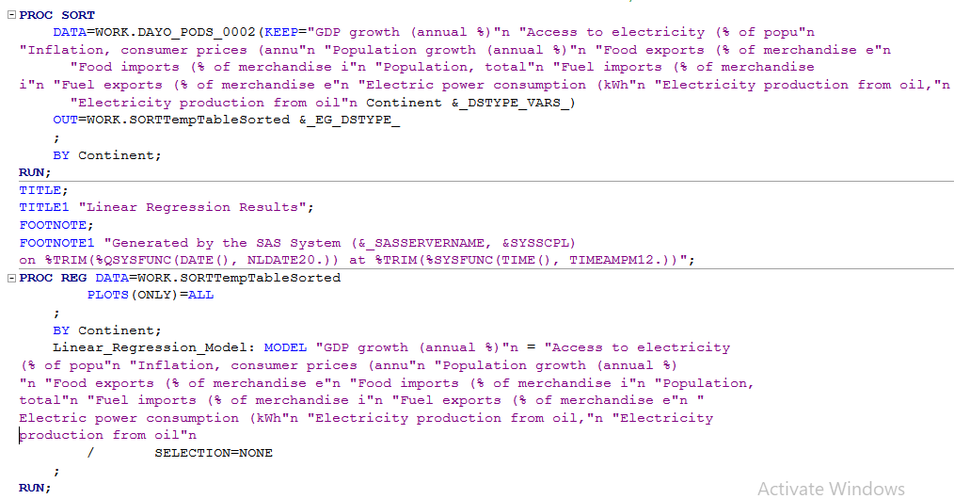

**Hypothesis Testing with GDP**

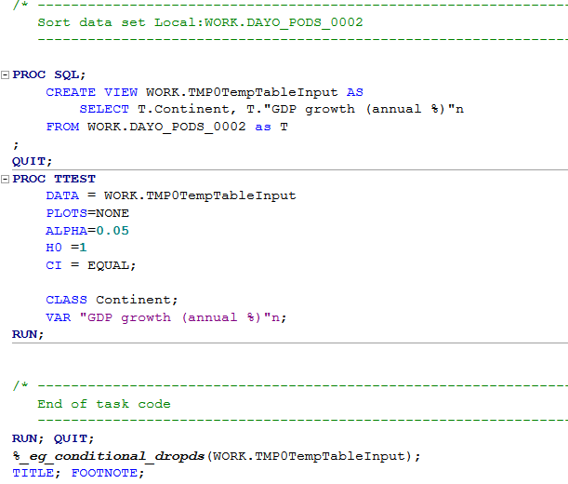

**Hypothesis Testing with Population Growth**

